

New Student Information Guide

TABLE OF CONTENTS
How do I get a NetID? 3
How do I get a Rutgers email account? 4
How do I get a student ID card? 4
Am I required to be vaccinated against COVID-19 before registering? 4
What other vaccinations are required? 4
Are the GSE policies online? 4
How do I apply for licensure? 4
How do I know which courses to take? 4
How do I know who my advisor is? 5
Where can I find my advisor’s contact information? 5
I’m having trouble finding/contacting my advisor, what should I do? 5
How do I register for courses? 5
Where are Rutgers University Bookstores? 6
Can I buy my books online? 6
Where do I log in to CANVAS? 6
I want to plan for next semester, how do I view available courses? 6
Where can I find the registration schedules and the academic calendar for holidays, exams, etc.? 6
How do I know if courses are cancelled due to inclement weather? 6
How do I view my grades? 7
Where can I order a copy of my Rutgers transcripts or request enrollment verification? 7
How do I pay my term bill? 7
How do I grant access (to my parents, etc.) to my private information? 7
Is financial aid available? 7
Does the GSE offer scholarships and fellowships? 8
How do I proceed if I am a Tuition waiver student? 8
How do I find the location of specific University buildings? 8
Where can I study and/or research on campus? 8
Where are the computer labs? 8
How do I obtain a parking pass? 8
Where does my parking pass permit me to park on campus? 8
Where do I find a bus/shuttle? 9
Is there public transportation near campus? 9
Where can I get something to eat or just relax on campus? 9
Where do I find meal plan information? 9
Where are the gyms/recreation centers? 9
Are there GSE student organizations? 9
Is there a graduate student organization at Rutgers? 9
Is there an office of Veterans Services at Rutgers? 9
Are there campus activities available for graduate students? 10
Where are the health clinics/university doctor’s offices located? 10
Where are the local hospitals located? 10
Where can I find information about counseling services? 11
Where is the university police station located? 11
What do I do if I am uncomfortable walking around at night alone? 11
What do I do if I have a concern about someone or something? 11
Other important sites:
Rutgers University Code of Student Conduct 11
Graduate School of Education 11
Office of Student and Academic Services 11
Rutgers University 11
Rutgers Current Student Information 11

If you do not have a computer on campus, you will find Rutgers computer lab locations on page 8 of this guide.

How do I get a NetID?
- Go to this link.
- Click on “NetID Activation.”
- Fill out the online form with the appropriate information, then click “Continue.” Follow the instructions until complete.
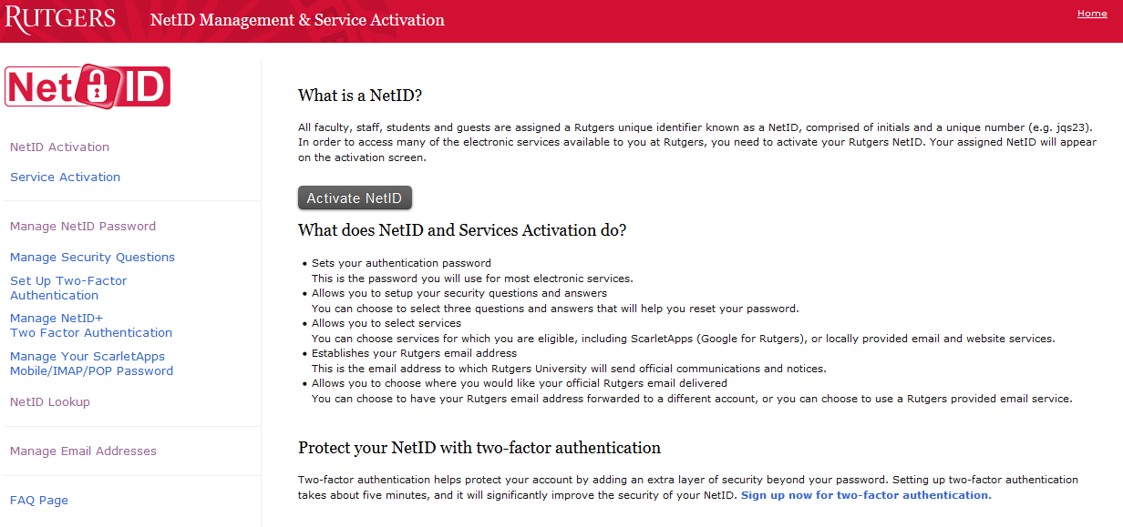

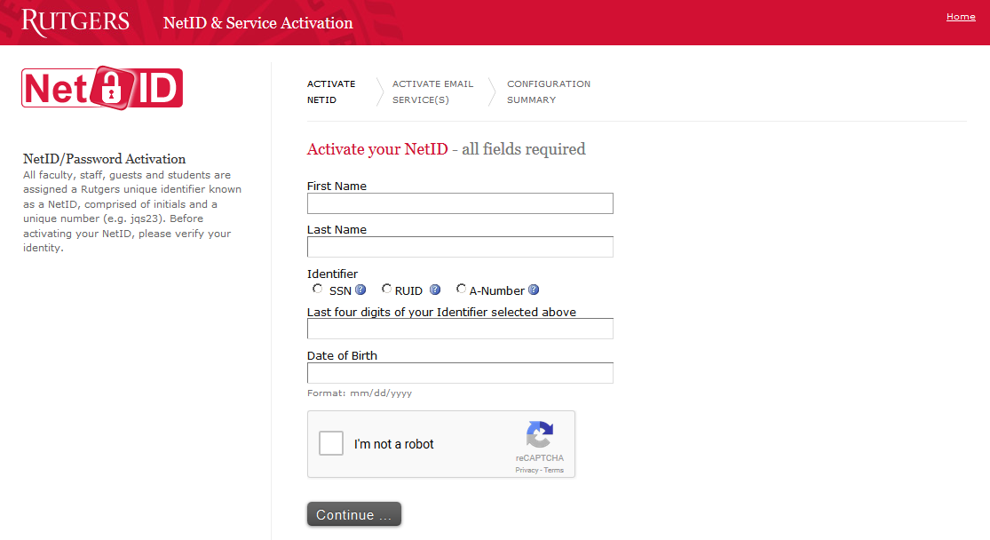

How do I get a Rutgers email account?
- It is assigned automatically when you receive your NetID.

How do I get a student ID card?
- ID cards can ONLY be obtained IN PERSON at any RU Connection office.
- For more information go to the RU Institutional Planning and Operations website.

Am I required to be vaccinated against COVID-19 before registering?
- As of April 1, 2024, Rutgers no longer requires students, faculty, and staff to be immunized against the COVID-19 virus.
- Please see the COVID-19 information website for more details.

What other vaccinations are required?
- Please see the Student Health webpage for a list of required and recommended vaccinations.

Are the GSE policies online?
- Yes, go to the Online Rutgers Catalog for New Brunswick
- Click on “Schools” in the upper-right corner of the screen, then select “Graduate School of Education,” then “Academic Policies and Procedures.”

How do I apply for licensure?
- If you are enrolled in a certification program, upon completion of your program the GSE will process your licensure nomination through the New Jersey Department of Education.
- Please reach out to Ken Tufo at ken.tufo@gse.rutgers.edu for more information.

How do I know which courses to take?
- All students are assigned an advisor at the time of admission. Students should consult with their advisor regarding course requirements. Students can review program requirements by looking up their program on the GSE website.
How do I know who my advisor is?
- Your advisor is listed on the Certificate of Admission letter you can download from the Graduate Admissions application portal.

Where can I find my advisor’s contact information?
- The Certificate of Admission should include your advisor’s email address. You can also check the Faculty & Staff directory on the GSE website.

I’m having trouble finding/contacting my advisor, what should I do?
- Contact your Office of Student and Academic Services representative or email OSAS at academic.services@gse.rutgers.edu.

How do I register for courses?
- You can register online at Webreg.
- You can register by logging in with your NetID, RUID, or PAC.
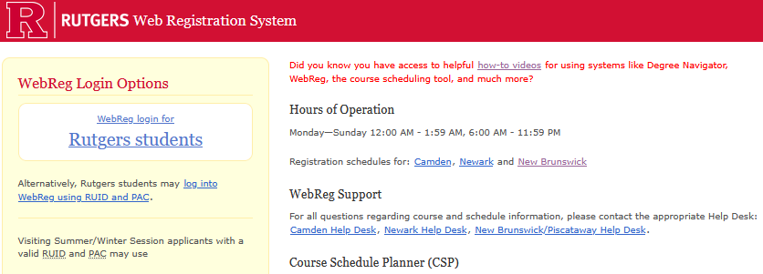
- If you do not have a NetID, register for your first class(es) using your RUID or PAC.
- Select the appropriate semester and use the Course Lookup and Manage Registration tabs to register.
- If the course you wish to register for requires a special permission number, it will list a point of contact where you can get a number. If it doesn’t list a point of contact, contact the Office of Student and Academic Services for assistance at academic.services@gse.rutgers.edu.
Where are Rutgers University Bookstores? Can I buy my books online?
- Books can be bought online at this link.
- Also, when registering for a class there will be a link that will take you to the books required for that class.

What if it says “course materials selection pending”?
- Contact the course instructor.

Where do I log in to CANVAS?
- Log in to CANVAS here.

I want to plan for next semester, how do I view available courses?
- Go to the online University Schedule of Classes to view all offered courses.
- From the main page, you can select which term, location, and undergraduate or graduate courses.

Where can I find the registration deadlines/schedules and the academic calendar for the start/end of semester, holidays, and exams?
- The RU Academic Calendar can be found here
- Please note: the GSE Graduate course schedule does not follow the Reading Days and Exam Week schedule shown on the New Brunswick Registrar academic calendar. The GSE Graduate academic calendar is 15 weeks.
- The New Brunswick Graduate Registration Calendar can be found here.

How do I know if courses are cancelled due to inclement weather?
- Go to the Rutgers New Brunswick Operating Status page.

How do I view my grades?
- Student Unofficial Transcript & Grades can be accessed online.
- Login with your NetID and password.
- You can also access your grades, schedule, and more by logging in at myRutgers.

Where can I order a copy of my official Rutgers transcripts or request enrollment verification?
- Official transcripts and enrollment verification can be requested online at the Transcript/Enrollment Certification & Term Grade Report System.

How do I pay my term bill?
- Term bills MUST be paid online at the Student Accounting, Billing, and Cashier Services website.

How do I grant access (to my parents, etc.) to my private information?
- To give consent for parents, guardians, and third parties to access your private information, go to the Resources for Student Success website.
- Search for “myguest” on the keyword line.
- Then click on the “+” icon to expand the instructions for using myGuest.
- There will be instructions and a link to the myGuest Dashboard.

Is financial aid available?
- Usually. For more information go to the RU Scarlet Hub Financial Services webpage.
- NOTE: For most financial aid and loans, graduate students are typically expected to be enrolled at least “half time” – 4.5 credits – or more. Be sure to consult with Financial Aid and/or your loaning institution for rules regarding this policy.
- Non-degree students interested in financial aid should contact Colleen McDermott at colleen.mcdermott@gse.rutgers.edu.

Does the GSE offer scholarships and fellowships?
- Degree-seeking students are eligible; please take a look at the information provided on the GSE website.
- Non-degree students are not eligible for GSE scholarships and fellowships.

How do I proceed if I am a Tuition Waiver student?
- Contact the New Brunswick Registrar.

Where can I find information about campus housing?
- Information about on-campus housing for new students can be found on the Residence Life website.

How do I find the location of specific University buildings?
- You can search for specific locations on the RU interactive campus map.

Where can I study and/or research on campus?
- Information can be found on the Rutgers Libraries homepage.

Where are the computer labs?
- Locations of campus computer labs and more can be found on the RU Office of Information Technology (OIT) homepage.

How do I obtain a parking pass?
Where does my parking pass permit me to park on campus?
- Parking information can be found on the RU Institutional Planning and Operations Parking Services page.
- If you are unsure which lots correspond to your permit submit a request at RU DOTS Help.
Where do I find a bus/shuttle?
Is there public transportation near campus?
- The RU Institutional Planning and Operations page has information on New Brunswick busses and shuttle services.

Where can I get something to eat or just relax while on campus?
Where do I find meal plan information?
The GSE offers a comfortable study lounge in the main lobby of our building.
- For dining hall locations and other options, see the Dining Services page.
- Meal plan information can be found on the Dining Services Meal Plans page.
- To find the student centers, see the Student Centers and Activities page.

Where are the gyms/recreation centers?
- The Student Affairs Recreation page has that information.

Are there GSE student organizations?
- Information on the GSE Student Affairs Committee (GSAC) can be found on the GSAC homepage.

Is there a graduate student organization at Rutgers?
- Check out the Graduate Student Association at the GSA homepage.

Is there an office of Veterans Services at Rutgers?
- Information can be found on the Office of Veteran and Military Programs and Services page.

Are there campus activities available for graduate students?
- Visit the getINVOLVED page for events and organizations.
- The Student Affairs Recreation page has information on intramural sports, club sports, and recreation classes.
- Arts and cultural information can be found on the Student Experience / Arts and Culture page
- Explore the on-campus and off-campus attractions that Rutgers offers on the Discover Rutgers page.
- For other graduate opportunities visit the Discover Rutgers Research page.

Where are the health clinics/university doctor’s offices located?
- Information can be found on the Student Affairs / Student Health page.

Where are the local hospitals located?
- St. Peter's University Hospital: 254 Easton Ave, New Brunswick
- Robert Wood Johnson Hospital: 1 Robert Wood Johnson Place, New Brunswick
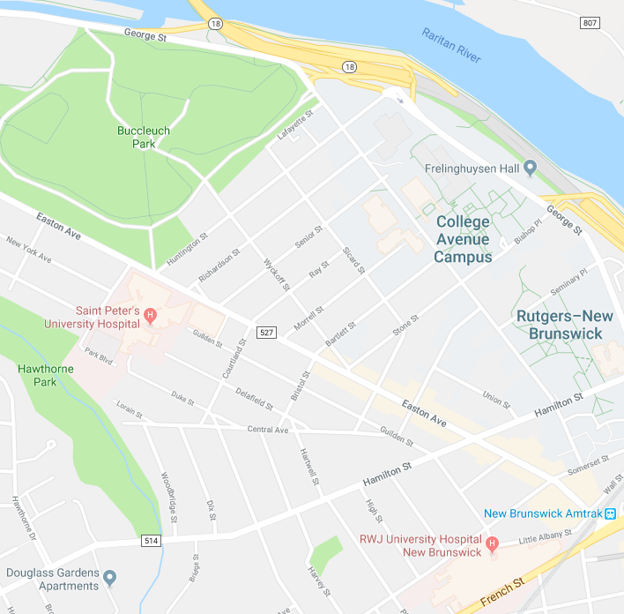

Where can I find information about counseling services?
- Information on counseling services can be found on the Student Health / Counseling Services page.

Where is the university police station located?
- Rutgers Police Department, Public Safety Building, 55 Commercial Avenue, New Brunswick, NJ 08901. More information can be found on the University Public Safety page.

What do I do if I am uncomfortable walking around at night alone?
- Escorts are available. Information can be found on the Escorts page of the University Public Safety website.

What do I do if I have a concern about someone or something?
- To report a concern please go to the Student Health Do Something to Help page.

Other important sites:

Rutgers University Code of Student Conduct

The Graduate School of Education homepage:
- Ed.M. programs
- Ed.D. programs
- Ph.D. programs

Office of Student and Academic Services

Rutgers University homepage

Rutgers Current Student Information

