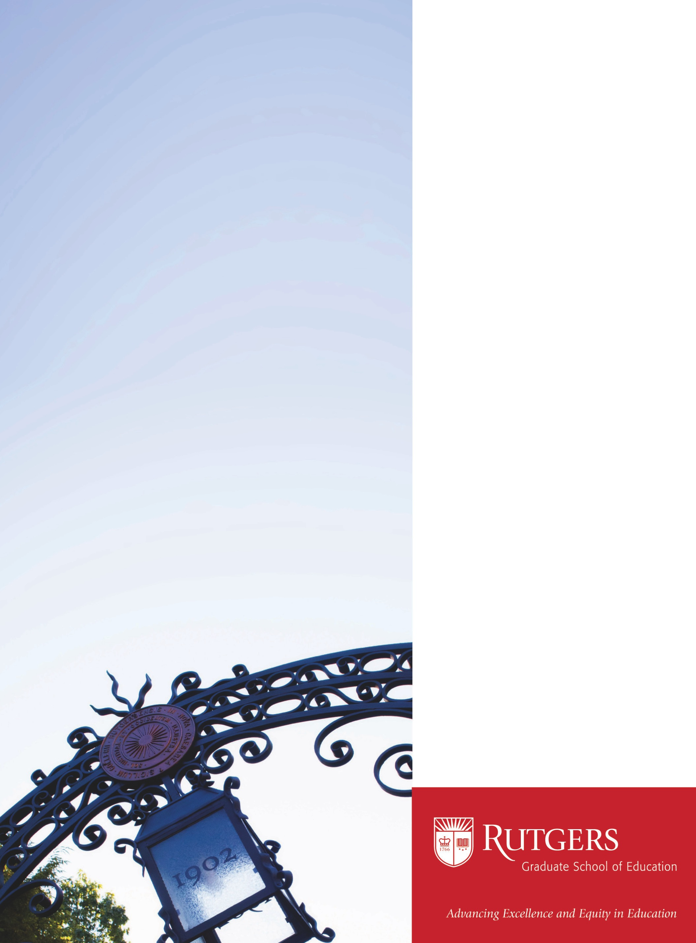

ESL, Low Literacy and the Adult

Learner: Mapping the Field

(Spring Semester)

Effective Reading and Writing

Instruction for Adult Basic

Education Students

(Summer Semester)

Effective Reading and Writing

Instruction for GED and

Developmental College Students

(Summer Semester)

Instruction to Adult and

Continuing Education

(Fall and Spring Semester)

OR

Understanding the Adult Learner

(Fall and Summer Semester)

For more information,

please contact Alisia Belzer,

Program Coordinator

alias.belzer@gse.rutgers.edu

Courses:

 

■ All courses are offered 100% online

■ No program pre-requisites required

Rutgers Graduate School of Education is now

offering a 12 credit Graduate Certificate in Adult

ESL and Literacy Education.

This program is designed for those working or

interested in working in adult basic education

settings and who want to improve their skills and

knowledge to better meet the needs of adult students.

These courses can also be counted towards a Rutgers

Graduate School of Education 30 credit, fully online

Masters Degree in Adult and Continuing Education.

Online

Certificate

in Adult ESL

and Literacy Education