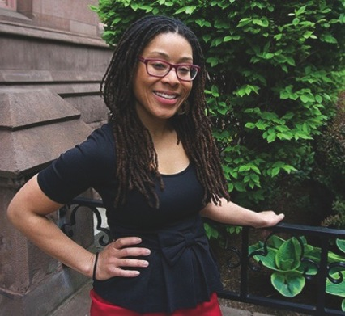

Lauren Leigh-Kelly

Assistant Professor Urban Teaching Education

10 Seminary Place, New Brunswick, NJ 08901

848-932-7486 / gse.rutgers.edu

Wednesday, December 10th, 2016

9:30 to 10:30 pm

GSE Lecture Hall, Room 124

This presentation discusses data from two studies of high

School classrooms engaged in critical literacy practices and

social justice education. The first is a case study that examines

the use of critical Hip Hop literacies in an English elective

course entitled ”Hip Hop Literature and Culture.” Through

engagement with critical media literacy practices and dialogic

inquiry, the students in this class began to develop complex

ideas about power and equity, especially concerning race,

class, and gender. Additionally, they began to see themselves

as change agents in their communities. The second study

discussed involves ethnographic observations of two urban

high schools whose missions are dedicated to social justice

and civic engagement. This ongoing study examines the classroom practices that foster young people’s critical

consciousness, especially concerning race and class inequality,

and participation in social action projects. Both studies

highlight the ways in which adolescents display agency and

literacies of empowerment through engagement in critical teaching and learning practices in the secondary classroom.

Developing Critical

Consciousness and Literacies

of Empowerment in the

Secondary Classroom