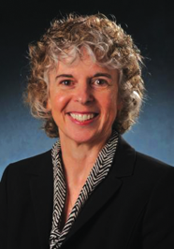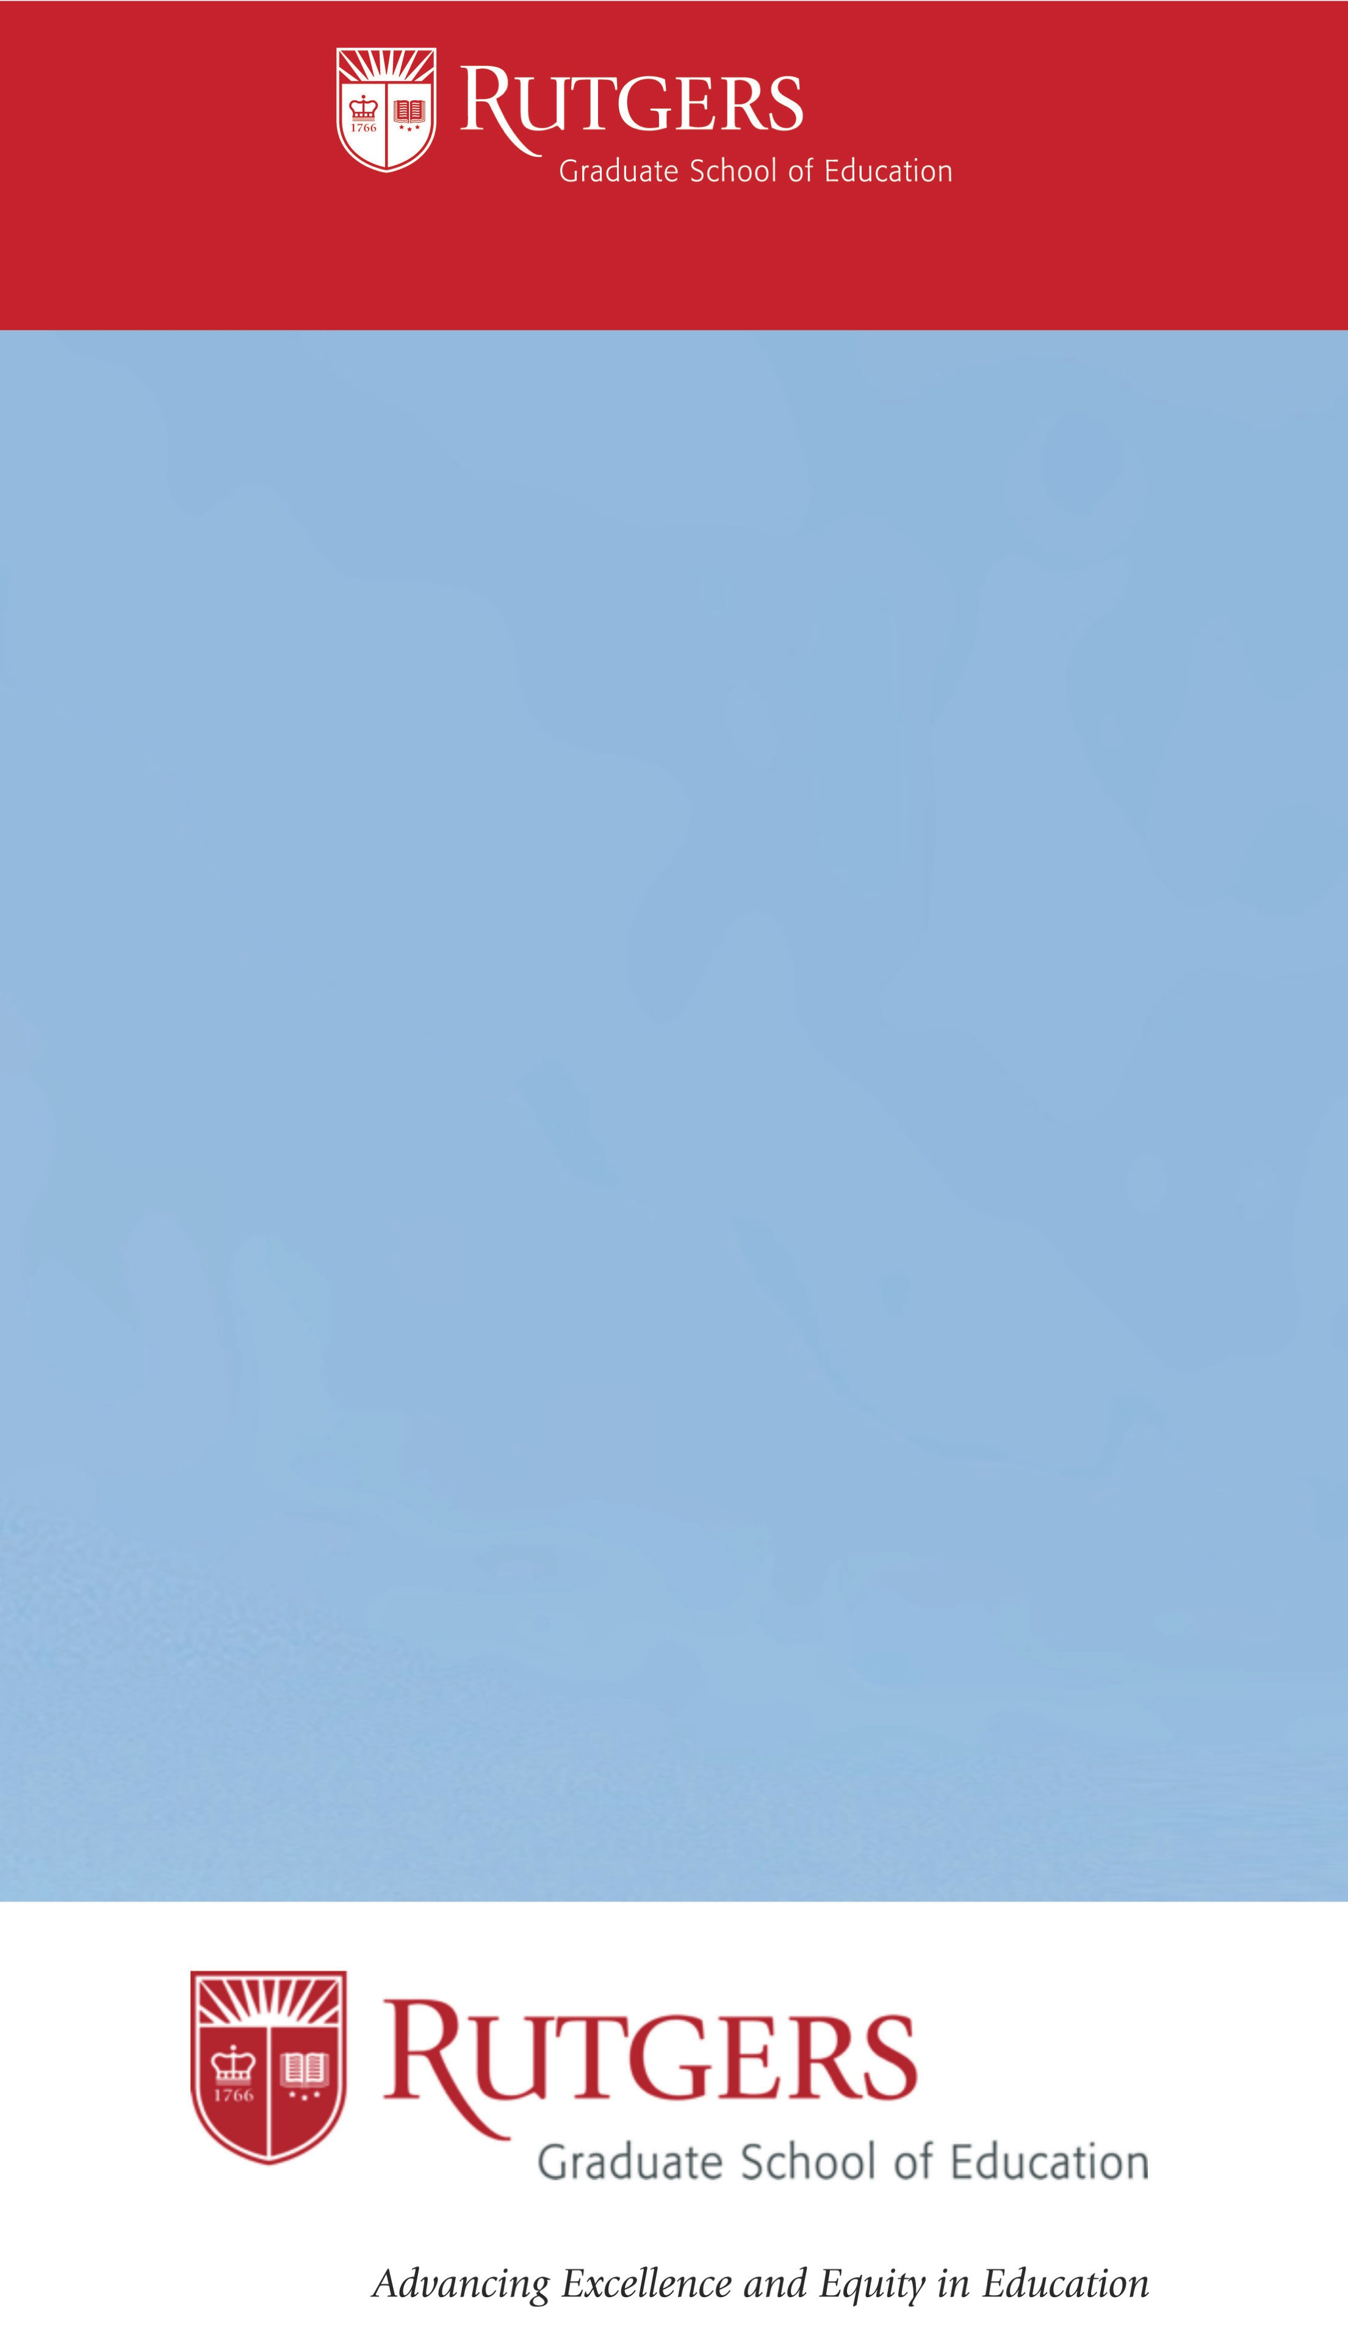

We cordially invite you to the fourth annual

DeMarzo Lecture Series on Teaching Excellence. This

lecture series features outstanding scholars addressing a broad range of issues around teaching. Dr. Lorrie

Shepard, Distinguished Professor in the School of

Education at the University of Colorado Boulder, will

give this year’s lecture.

Dr. Shepard’s current research examines psychometrics

and the use and misuse of tests in educational settings.

Additionally, Dr. Shepard’s technical work has

contributed to validity theory, standard setting, and statistical models for detecting test bias. Her research studies on test use have addressed the identification of learning disabilities, readiness screening for kindergarten, grade retention, teaching testing, effects

of high-stakes accountability testing, and most recently the use of classroom assessment to support teaching

and learning. Please see flyer for the abstract on

Dr. Shepard’s lecture.

Seats are limited, so if you plan to attend this event, please register below and feel free to share this

invitation with interested colleagues.

We look forward to seeing you in February.

Wednesday, February 1, 2017

3:30 pm – Reception to Immediately Follow

Edward J. Bloustein School of Planning and Public Policy

33 Livingston Ave

New Brunswick, NJ 08901

DeMarzo Lecture Series on Teaching Excellence